Vincent: What to Expect
Vincent is a big smart dog who is looking for a special home. Vincent needs to find a dog experienced, adult-only home with a patient, calm and confident person who has time to continue working on training using the same positive reinforcement techniques we use at OHS. He would not do well in a home with a lot of hustle and bustle, or one with children. Vincent is a big dog with a big personality, who loves people. When excited Vincent likes to jump up on his humans and if overstimulated will grab onto loose fitting clothes, the leash, or purses/bags. We’ve been very successful using positive training techniques, asking Vincent to sit and wait for pets and to have him pick up toys to help him with impulse control.
Vincent does well with potty training when he can stick to a routine and has a predictable schedule. Be prepared for accidents as he settles in.

Vincent is on our running team and is a delight to go on runs with his volunteers. He would thrive in an active and/or adventurous home but be aware that he does best in calmer, less stimulating outdoor environments so the Springwater Corridor or crowded areas would not be places you should take him.

Vincent does not do well with out-of-control greetings, such as a dog running up into his face when on leash or at off leash dog parks and having been in a shelter environment for some time, he easily becomes overstimulated when he sees other dogs. He is much better in a calm, less chaotic environment that you can control.
Here’s how to help Vincent settle in during your first months together:
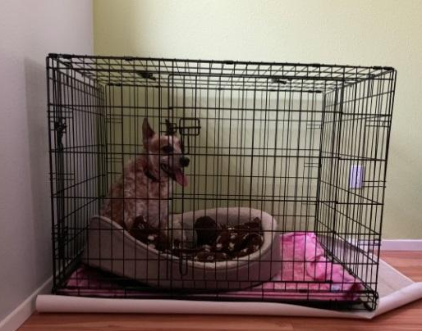
Use treats to build trust. Continuing his training will create a strong bond.

Designate a “safe spot” in your home. You can use a crate to confine him to a smaller area where he has access to water, bed, and toys (see picture). When you are unable to supervise him, leave him in his safe spot.
Practice home alone training. Vincent may whine or bark if left home alone for extended periods of time. We’ve also begun working on crate training. To continue crate training, feed his meals in the crate and work your way up from there.

Be his advocate. It’s okay to ask someone to stop or prevent a person or dog from coming up to say hi to your dog. Watch his body language and help him out of situations if he appears stressed.
Vincent needs daily exercise to reduce stress. Vincent loves to go for runs and for long walks in quiet environments. Giving him a healthy outlet for some of his energy will help him settle during calm hours at home.

Work on having him settle on a mat and gently praise him for lying down. If he gets up to pace, call him back and use a treat to lure him into a down again. If he is on leash, you can hold him with approx. 4 feet of leash and wait until he offers a settle by lying down. Softly praise and treat when he does this.

Skip the dog park! Don’t take him to busy places where he will have lots of uncontrolled interactions with people or other dogs (such as Saturday Market, dog parks, coffee shops, etc.).
Practice "Leave it.” Vincent may bark and lunge if he sees people or other dogs when he’s on a walk. When he sees a dog or stranger, before he starts barking, say “Vincent, leave it.” When he turns to look at you, reward with praise and a treat and walk away from the trigger. Distance is calming.
Visiting the Vet: Unless it’s an emergency, give your dog plenty of time to bond to you before taking them to your vet. Start with positive visits just for treats. Vet visits will more than likely be scary, but if your dog already trusts you, your presence may help them feel more comfortable.
Try using Adaptil (Dog Appeasing Pheromone) or Rescue Remedy by Bach Flower Essences. These products may help dogs settle in new environments by easing the stress associated with change.
Patience will come in handy for you. Vincent is a sensitive dog who responds best to positive reinforcement and reward-based training. He needs an understanding, calm owner who has the time and desire to work with him. He will pay you back by supplying love and enthusiasm!

We’re here to help!
We want Vincent to be successful in your home. We’re available to answer training and behavior questions via phone and email. Just call 503-416-2983 and leave a message on our free Behavior Help-Line.
Please keep in touch so we can continue to help you now and in the future. Reach out if you have questions or concerns, or just to give an update. We love to see photos and hear how our friends are doing! Thank you for adopting from the Oregon Humane Society. Congratulations on your new dog!

Behavioral Medication for your New Dog
This dog has been prescribed one or more medications to help reduce anxiety and impulsivity during his/her time in the shelter. You may be provided with a supply of this dog’s medication(s) along with specific dosing instructions at the time of adoption.

We would recommend that you continue giving this medication for at least the first 6 months after adoption to help reduce stress that may be associated with this dog making a smooth transition into your home. It is difficult to predict whether this dog will benefit from treatment over an even longer period of time – this is something that we ask you to discuss with this dog’s new veterinarian when you take him/her in for your first exam.

When it appears time to stop giving your dog these medications, please contact your veterinarian for an appropriate weaning off protocol and to make sure you have enough medication to allow for a weaning off process.

During this process, please watch for any signs of worsening anxiety or impulsivity. If the dog appears to be getting worse during the weaning off process, contact your veterinarian as longer treatment may be needed.

