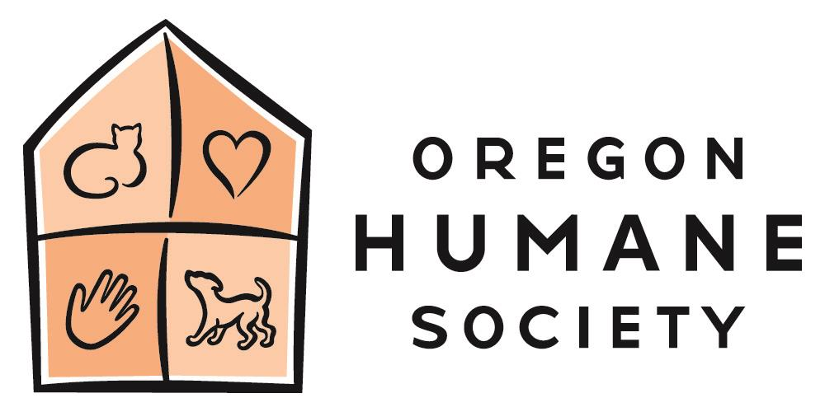
Summer Camp 2022
VOLUNTEER JUNIOR CAMP COUNSELOR

The Oregon Humane Society is seeking Junior Camp Counselors to volunteer for the youth summer camps. Successful candidates are enthusiastic, responsible, self-motivated and are positive communicators. A warm, creative and compassionate attitude is needed.

RESPONSIBLE TO: Lead Counselor and Group Leader

GENERAL RESPONSIBILITIES:
Jr. Counselors are assigned to a color group with 3-4 other Jr. Counselors and a lead Counselor, and as a team, they help the campers stay safe and have fun on a daily basis. Jr. Counselors help lead groups (8-10 campers per group) to each of their daily activities revolving around the shelter animals and camp activities. As role models, Jr. Counselors create one-on-one relationships with campers and develop a supportive group environment for the each session. Jr. Counselors are expected to engage campers with conversation, games, stories, and take a lead role in directing the behavior of their campers throughout the day. Jr. Counselors will support the staff and animal wranglers at each activity station by managing camper behavior and assisting with instructional tasks.

SPECIFIC RESPONSIBILITIES:
1. Provide supervisory care for a group of up to 8-10 children of similar ages as a team with other Jr. Counselors and a lead Counselor.
2. Assist the camper group in working together: help campers have fun, practice animal safety, solve problems, ease conflicts, and learn to appreciate each other and the environment.
3. Fulfill group obligations to the whole camp: help with set-up and clean-up activities, arrive as a group on time to activities, create a positive personality for the group.
4. Be a positive role model for your campers.
5. Keep the kids safe and healthy.
6. Interact with campers and animals during stations.
7. Be aware of where your campers are at all times.
8. Foster positive relationships among camp staff, campers and camper parents.
9. Share in designing, leading and carrying out free-time activities.
10. Actively engage in OHS’ mission to Create a More Humane Society and to create an inclusive camp.

HOURS:
Counselor hours are 9:00am-4:00pm Monday – Friday.

MINIMUM QUALIFICATIONS:
- Age: 9th grade and above
- Sincere respect and passion for animals and children.
- Care and understanding of creating a positive learning environment.
- Ability to work well in a small community and have fun!
- Possess punctuality, flexibility, energy and enthusiasm.

PREFERRED QUALIFICATIONS:
- Previous animal experience
- Previous childcare experience
- Previous camp experience

