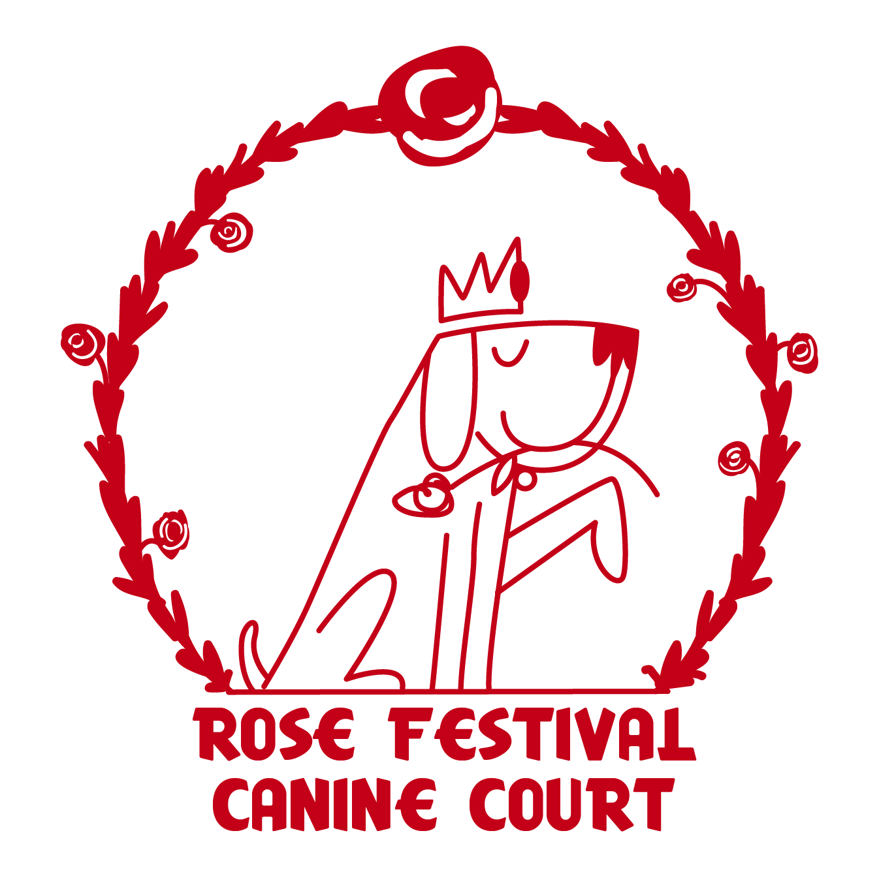

2018 Portland Rose Festival Canine Grand Marshal and Court Application
Overview: The Oregon Humane Society and LexiDog Boutique and Social Club are hosting the “2018 Portland Rose Festival Canine Grand Marshal and Court” selection competition.
- 20 Canine Finalists will be chosen to participate in the Canine Coronation Ceremony
- 4 Canine Princesses/Princes will be chosen for the Canine Court at the Canine Coronation Ceremony
- 1 Canine Queen/King will be chosen as the Canine Grand Marshal for the 2018 Rose Festival Parade
Important Dates:
- April 2 – Contest open
- May 14, Noon – Contest closes
- May 15 – Finalists notified
- May 23 – Canine Grand Marshal and Court Coronation Ceremony at the Heathman Hotel
- May 25 – Opening Day at the Rose Festival City Fair
- June 9 – Rose Festival Grand Floral Parade
Applicant Requirements & Responsibilities:
- Application fee is $50; 100% of proceeds will be donated to Oregon Humane Society.
- Male and female dogs may apply. There are no restrictions on the number of males vs females on the Court. The Grand Marshal may be male or female.
- Canine Requirements: All dogs must be current on vaccinations, and dogs over 6 months of age must be spayed/neutered to be eligible.
- Canine Court Princesses and Princes will be chosen based on personality, poise, presence, platform and talent by a panel of celebrity judges.
- Dogs must be:
  - Well-poised (be at ease and well-behaved in different settings, with all types of people and dogs).
  - Well-traveled (comfortable on a leash and riding in a vehicle).
  - Have a flexible social calendar to be available when duty calls:
    - If chosen as a finalist, attend the Canine Coronation Ceremony event on Wednesday, 5/23 from 5-9 PM at the Heathman Hotel to compete for a selection as a prince/princess of the court or the Grand Marshal position.
    - If chosen as the Canine Grand Marshal, ride in a car at the Grand Floral Parade on June 9th.
Canine Grand Marshal and Court Coronation Ceremony:
- 20 finalists will receive a gift basket valued at approximately $100.
- The 4 Prince/Princesses of the Court will receive a gift basket valued at approximately $500.
- The Canine Grand Marshal will receive a gift basket valued at approximately $1,000, and of course, have bragging rights for being the only canine Grand Floral Parade Grand Marshal ever!
The public is invited to attend the Canine Grand Marshal and Court Coronation Ceremony on May 23 at the Heathman Hotel. Visit oregonhumane.org/caninecourt for tickets. Space is limited.
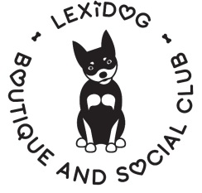
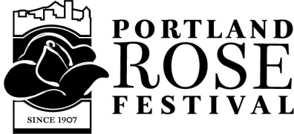

2018 Portland Rose Festival Canine Grand Marshal and Court Application
Seeking a Canine Grand Marshal for the Grand Floral Parade
Entry Deadline: Noon, May 14, 2018
(Personality Shot)
Affix photo here
(Head Shot)
Affix photo here

Please note that pictures will not be returned. Also, by entering you are allowing your dog’s entry form and photos to be posted by LexiDog, the Portland Rose Festival and the Oregon Humane Society for public viewing.
My name is , I am years old.
I am a (breed(s)) and I weigh lbs.
Questions:
Personality:
- I’m all about this year’s Rose Festival theme of “Play Happy”. My style of play is:

Platform:
- If I could get one message (my “motto”) out to the world, it would be:

Presence:
- My special charm that wins over my family’s heart is:

Talent:
- My winning talent (or favorite activity) is:

Portland Representation:
- I can best represent dogs in Portland because:

Official Entry Form Contact Information

My parent(s) name is:
Phone: Email:
Application fee is $50; 100% of proceeds will be donated to Oregon Humane Society.
Event Details:
Fifteen canine court finalists will be selected and notified on May 15th. Finalists are asked to attend the
Canine Grand Marshal and Court Coronation Ceremony on Wednesday, May 23rd from 6-9 pm, at the Heathman Hotel, where the 4 Canine Court Princesses/Princes plus 1 Grand Marshal King/Queen will be chosen by a celebrity judge panel.
Drop off or mail your entry to any of these LexiDog locations:
Pearl District: 416 NW 10th Ave., Portland, OR 97209
On Macadam: 6100 SW Macadam Ave., Portland, OR 97239 (behind Starbucks)
Lake Oswego: 131 N State St., Lake Oswego, OR 97034
Southeast: 2929 SE Powell Blvd., Portland, OR 97202

LexiDog use only
Date received: Entered at (circle one): Pearl Macadam Lake O Southeast
$50 Entry fee Paid (circle one): Yes No Payment Type (circle one): Check Cash Credit

