Special Needs Puppy - What to Expect
This sweet puppy was not socialized well which has left him more on the nervous and cautious side. When overwhelmed he panics and shows this by barking, lunging, snapping and rushing up to other dogs who he feels are stealing his resources. It is crucial for you to continue to introduce him to the big wide world slowly, safely and with his best interest in mind.

The key to building a confident dog from a worried puppy is to not allow strangers or novel dogs to greet him but to pair treats with him looking at the world from a safe distance, to associate new things with something positive. (See handout “Socializing your new dog”).

Introduce him to friends and their dogs after he has fully adjusted to you and your home and then do it only through structured play dates, positive reinforcement training, and using other gentle and confident dogs to model behavior. He is smart and eager to learn and engage with you, but he is concerned about resources (including your attention) and may react out of fear of losing them. He may always be a less confident dog and have moments of being overwhelmed. The slower you open up his world the better and at every stage, he should be confident and happy before you progress to the next stage. He is motivated to learn so the journey should be a positive one
Here’s how to help a Special Needs Puppy settle in during your first months together:

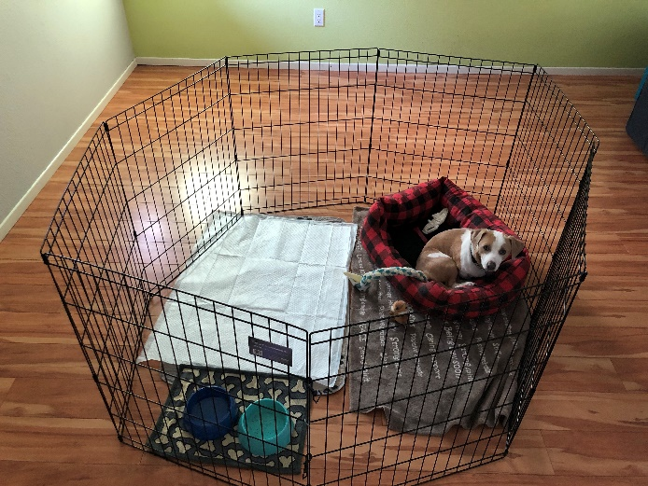
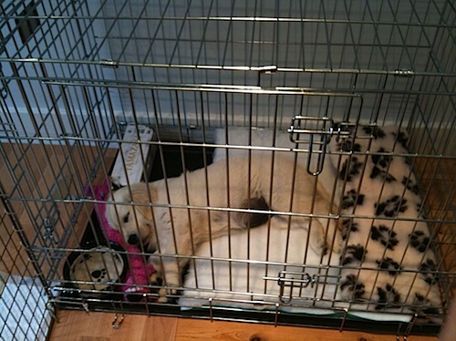

Designate a “safe spot” in your home. You can use a crate or taller baby gates for confinement in a smaller area with access to water, bed, and toys. When you are unable to supervise the dog, leave them in their safe spot. Slowly work toward leaving them alone, unsecured, once they’ve had the chance to settle into your home and you know with certainty, they will be comfortable.

“Puppy proof” your home and practice tether training indoors to prevent him from getting into puppy/adolescent trouble. When you first get home, keep him attached to you or tethered to a large piece of furniture as you go about your daily routine. This will help with potty training, bonding, and creating boundaries within the home. Let him drag the leash around the house or yard from time to time to simulate “freedom,” but do not let him off leash until he doesn’t need your guidance. This could take up to a few months.

VERY IMPORTANT: Be your dog’s advocate. It’s okay to ask someone to stop or prevent a person from letting their dog come up to say hi to your dog. Watch body language and help your dog out of situations if he appears stressed and before he has to defend himself. Explain that he is not yet comfortable with people or dogs approaching him.
Give him a treat from a distance to associate positive things when he sees people and dogs etc.

Patience will come in handy for you. Special Needs Puppies responds best to positive reinforcement and reward-based training and need time to properly adjust and gain confidence. They will need an understanding, calm owner who has the time and desire to work on helping him learn to live in a home and to slowly desensitize him and to teach him how to calmly interact with the world around him.

Training help. This puppy would benefit from taking a private training session to create clear and precise communication so there are no misunderstandings. You can find more info about our training options on our website at (https://www.oregonhumane.org/training/training-at-ohs/).

Skip the dog park. Don’t go to busy places where they will have lots of uncontrolled interactions with people or other dogs (such as Saturday Market, dog parks, coffee shops, etc.). The dog park can be dangerous for young or shy dogs and create more fear and panic rather than confidence. Playing in the backyard or going to places not frequented by many other dogs / people will allow for exercise but keep your puppy calm and engaged with you. Schedule play dates with friends and known dogs to help him socialize while remaining safe, but please wait a few weeks to do this.
Visiting the Vet: Unless it is an emergency, give your dog plenty of time to bond to you before taking them to your vet. The vets’ office can be a scary place for dogs. Bringing tasty treats like cheese and/or hot dogs can help make the experience more pleasant.
Try using Adaptil (Dog Appeasing Pheromone) or Rescue Remedy by Bach Flower Essences. These products may help dogs settle in new environments by easing the stress associated with change.
We’re here to help!
We want this Puppy to be successful in your home. We’re available to answer questions via phone and email. For questions, please call our behavior help-line 503-416-2983 or email OHSTrainers@oregonhumane.org
We have lots of resources on our website and make sure you watch the free video on his profile page to set you up for success!
Please keep in touch so we can continue to help you now and in the future. Reach out if you have questions or concerns, or just to give an update. We love to see photos and hear how our friends are doing! Thank you for adopting from the Oregon Humane Society. Congratulations on your new dog!

